Harvest gap ba/gap/m2 by harvest gap size
inverse transformation

46 case(s) deleted due to missing data.

Dep Var: TRANSHARVBAG N: 43 Multiple R: 0.398 Squared multiple R: 0.158

Adjusted squared multiple R: 0.138 Standard error of estimate: 0.556

Effect | Coefficient | Std Error | Std Coef | Tolerance | t | P(2 Tail)
CONSTANT | 0.680 | 0.188 | 0.000 | . | 3.612 | 0.001
HARVGAPSIZE | 0.000 | 0.000 | 0.398 | 1.000 | 2.777 | 0.008

Analysis of Variance

Source | Sum-of-Squares | df | Mean-Square | F-ratio | P
Regression | 2.388 | 1 | 2.388 | 7.711 | 0.008
Residual | 12.695 | 41 | 0.310
*** WARNING ***
Case 8 is an outlier (Studentized Residual = 5.055)

Durbin-Watson D Statistic 2.007
First Order Autocorrelation -0.005

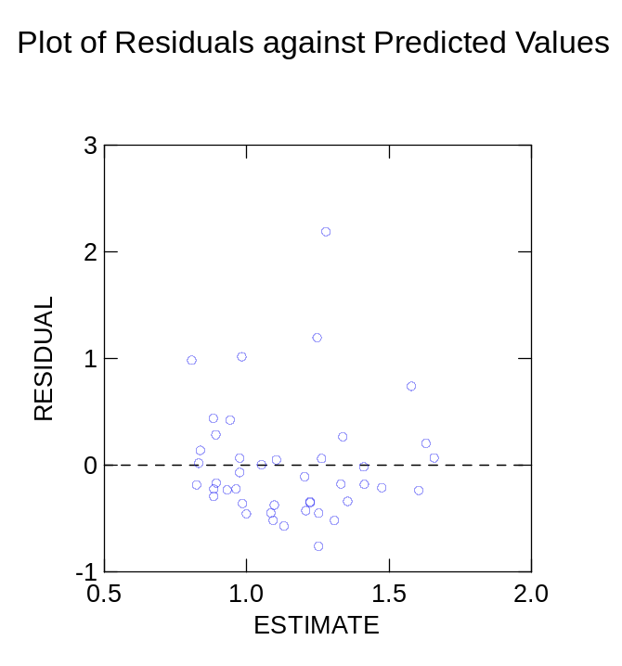

natural gap ba/m2/gap by gapsize
inverse transformation

61 case(s) deleted due to missing data.

Dep Var: TRANSNATBAG N: 28 Multiple R: 0.031 Squared multiple R: 0.001

Adjusted squared multiple R: 0.000 Standard error of estimate: 0.297

Effect | Coefficient | Std Error | Std Coef | Tolerance | t | P(2 Tail)
CONSTANT | 0.630 | 0.125 | 0.000 | . | 5.055 | 0.000
NATGAPSIZE | 0.000 | 0.000 | 0.031 | 1.000 | 0.157 | 0.876

Analysis of Variance

Source | Sum-of-Squares | df | Mean-Square | F-ratio | P
Regression | 0.002 | 1 | 0.002 | 0.025 | 0.876
Residual | 2.300 | 26 | 0.088
*** WARNING ***
Case 24 is an outlier (Studentized Residual = 4.033)

Durbin-Watson D Statistic 0.707
First Order Autocorrelation 0.643

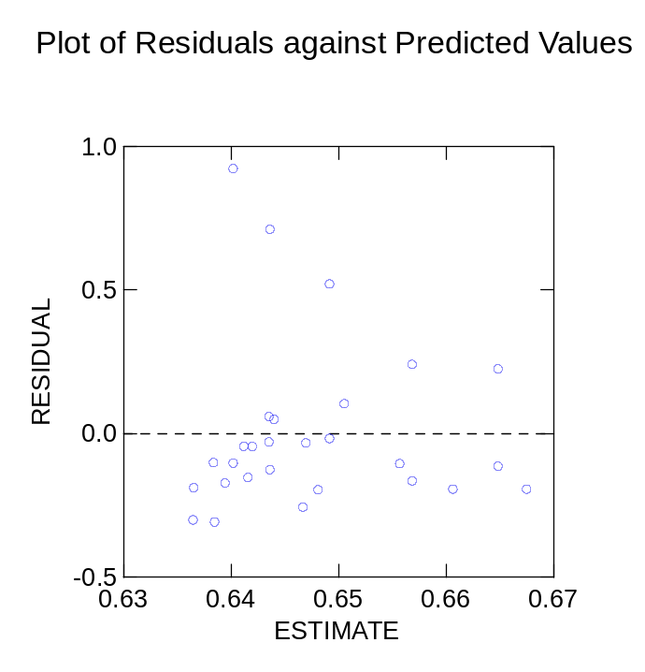

natural gap ba/m2/gap by gap size
log transformation

61 case(s) deleted due to missing data.

Dep Var: TRANSNATBAG N: 28 Multiple R: 0.109 Squared multiple R: 0.012

Adjusted squared multiple R: 0.000 Standard error of estimate: 0.380

Effect | Coefficient | Std Error | Std Coef | Tolerance | t | P(2 Tail)
CONSTANT | 0.590 | 0.159 | 0.000 | . | 3.700 | 0.001
NATGAPSIZE | -0.000 | 0.001 | -0.109 | 1.000 | -0.558 | 0.582

Analysis of Variance

Source | Sum-of-Squares | df | Mean-Square | F-ratio | P
Regression | 0.045 | 1 | 0.045 | 0.311 | 0.582
Residual | 3.762 | 26 | 0.145
*** WARNING ***
Case 24 is an outlier (Studentized Residual = -3.098)

Durbin-Watson D Statistic 0.623
First Order Autocorrelation 0.682

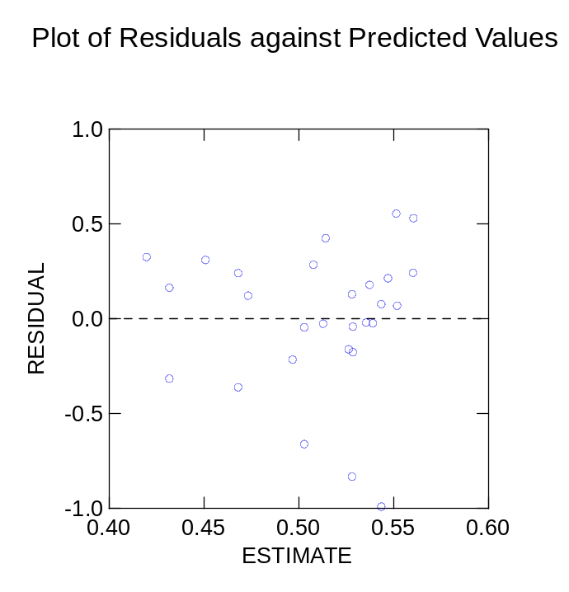

89 cases and 8 variables processed and saved.

SYSTAT Rectangular file C:\Documents and Settings\darci schofield\My Documents\Darci SAS files\ba by gapsize.SYD,
created Sat Jun 28, 2003 at 12:30:26, contains variables:

ORIGIN$ | TRANSNATBAG | TRANSHARVBAG | HARVGAPSIZE | HARVBAGAP | NATGAPSIZE
NATGAPBA | CLOSEDBAGAP

